STUDENT MANAGEMENT SYSTEM
Project Documentation Report
Technology Stack
HTML • CSS • JavaScript • Python • Django • Django REST Framework • SQLite
Prepared By
SRI SHARANYA M
Student Management System – CRUD-Based Full-Stack Web Application

1. Title and Project Overview
1.1 Project Title
Student Management System

1.2 Project Overview
The Student Management System is a web-based application developed to simplify the management of student information in an educational institution. It provides a centralized platform for storing, viewing, updating, searching, filtering, and deleting student records.
The application provides a professional dashboard where users can view useful statistics such as the total number of students, total departments, academic-year distribution, department distribution, and recent student records. The system also provides a dedicated student list and form-based CRUD operations.
The frontend is developed using HTML, CSS, and JavaScript. The backend uses Python, Django, and Django REST Framework. SQLite is used for data storage. The frontend communicates with the backend through REST API endpoints, allowing student records to be processed dynamically.

2. Problem Statement
Managing student records manually can become difficult as the number of students increases. Traditional approaches such as notebooks, spreadsheets, or separate files make searching, updating, and maintaining information less efficient. Manual record management can also lead to duplicate entries, outdated information, and difficulty accessing the latest records.
Educational institutions require an organized method to maintain student details such as Student ID, name, department, academic year, email address, and phone number. Without a centralized application, administrators or staff may spend additional time performing basic record-management tasks.
The proposed Student Management System addresses this problem by providing a centralized web-based solution. It enables users to add, view, update, search, filter, and delete student information through an interactive dashboard while keeping the data stored in a structured SQLite database.

3. Objectives
- Develop a simple and user-friendly web-based student management application.
- Provide an organized platform for maintaining student records.
- Implement complete Create, Read, Update, and Delete (CRUD) operations.
- Allow users to add, view, edit, and delete student information.
- Provide search functionality for quickly finding records.
- Provide department and academic-year filters.
- Display student statistics through a dashboard.
- Implement REST APIs using Django REST Framework.
- Store student information using SQLite.
- Validate important student fields before saving records.
- Provide a responsive and professional user interface.

4. Technology Stack
Technology | Purpose
HTML5 | Structure of web pages and forms
CSS3 | Styling, layout, and responsive design
JavaScript | User interaction and API communication
Python | Backend programming
Django | Backend web framework
Django REST Framework | REST API development
SQLite | Database and persistent data storage
VS Code / Antigravity IDE | Development environment
Google Chrome | Application testing and execution
Postman | Optional REST API testing
Git / GitHub | Version control and source-code sharing

Frontend
HTML provides the page structure, CSS provides the visual appearance and responsive layout, and
JavaScript handles forms, search, filtering, CRUD interactions, and communication with the backend.

Backend
Django manages the server-side application while Django REST Framework provides RESTful endpoints for student data.

Database
SQLite is used as a lightweight relational database. The database is stored locally in the project as db.sqlite3 and does not require a separate database server.

5. System Architecture
The application follows a client-server architecture in which the frontend communicates with the Django REST API. Django processes requests and interacts with the SQLite database.
USER | v +-------------------+
| FRONTEND |
| HTML + CSS + JS |
+---------+---------+
|
HTTP Requests | v +-------------------+
| REST API |
| Django REST |
| Framework |
+---------+---------+ | v +-------------------+
| DJANGO |
| BACKEND |
+---------+---------+ | v +-------------------+
| SQLite |
| db.sqlite3 |
+-------------------+
Working process: (1) the user interacts with the frontend, (2) JavaScript sends an HTTP request, (3) Django REST Framework receives and validates the request, (4) Django communicates with SQLite, and
(5) the response is returned to the frontend.

6. Database / ER Diagram

6.1 Student Entity
+----------------------------------+
| STUDENT |
+----------------------------------+
| PK id |
| student_id |
| name |
| department |
| year |
| email |
| phone |
| created_at |
+----------------------------------+
Field | Description
id | Unique database identifier
student_id | Unique student identification number
name | Student name
department | Student department
year | Academic year
email | Student email address
phone | Student phone number
created_at | Record creation date and time
The student_id field is unique so that duplicate student identification numbers are not accepted. The current design uses one primary Student entity because the application focuses on core student record management.

7. UI Screenshots
The following screenshots should be inserted in this section in the final printed/submitted version. The current application dashboard has been verified to display the StudentPro interface with the backend status shown as Online (Django API).
Figure 1: Student Management System Dashboard
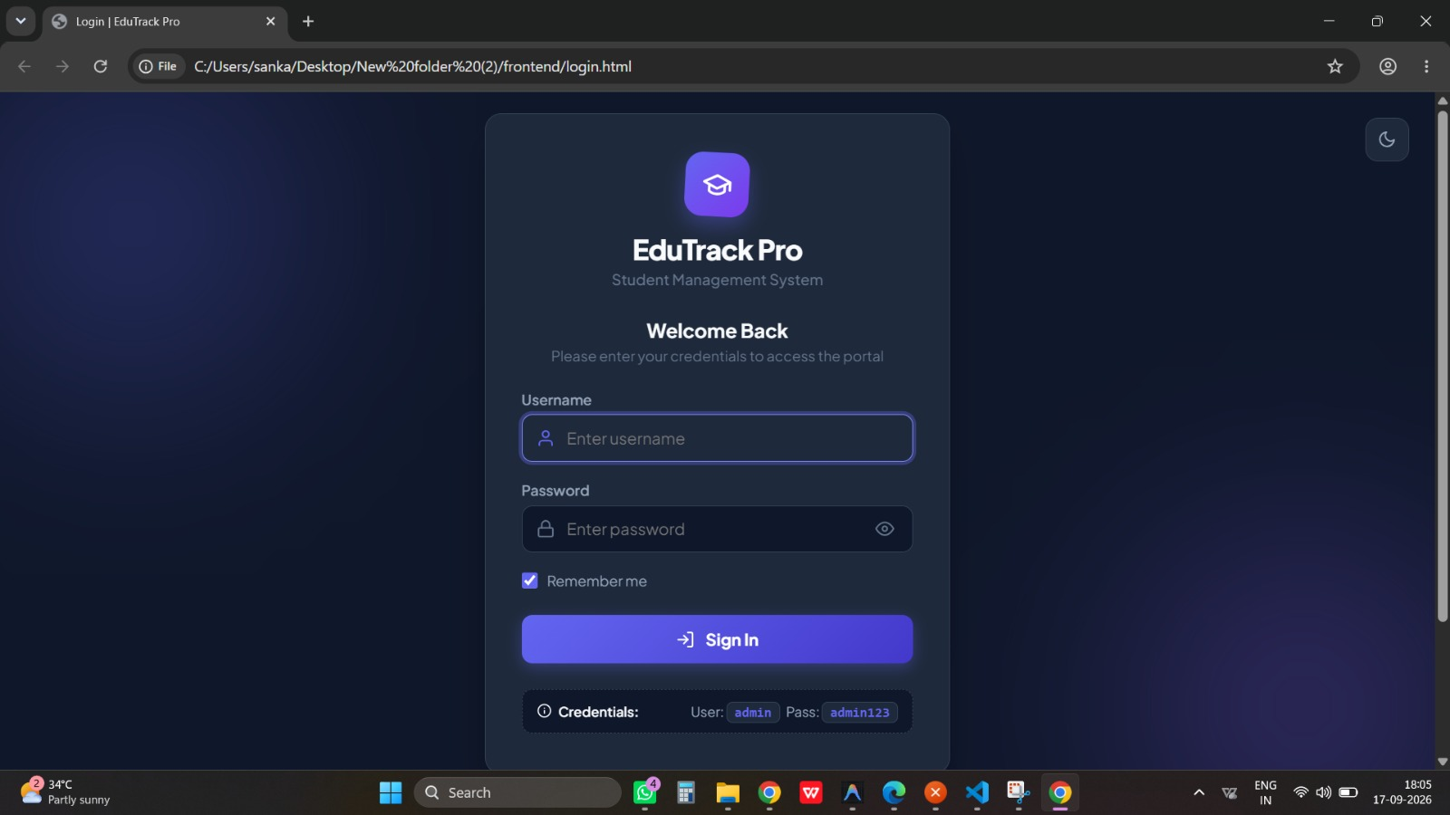
Figure 2: Add Student Form
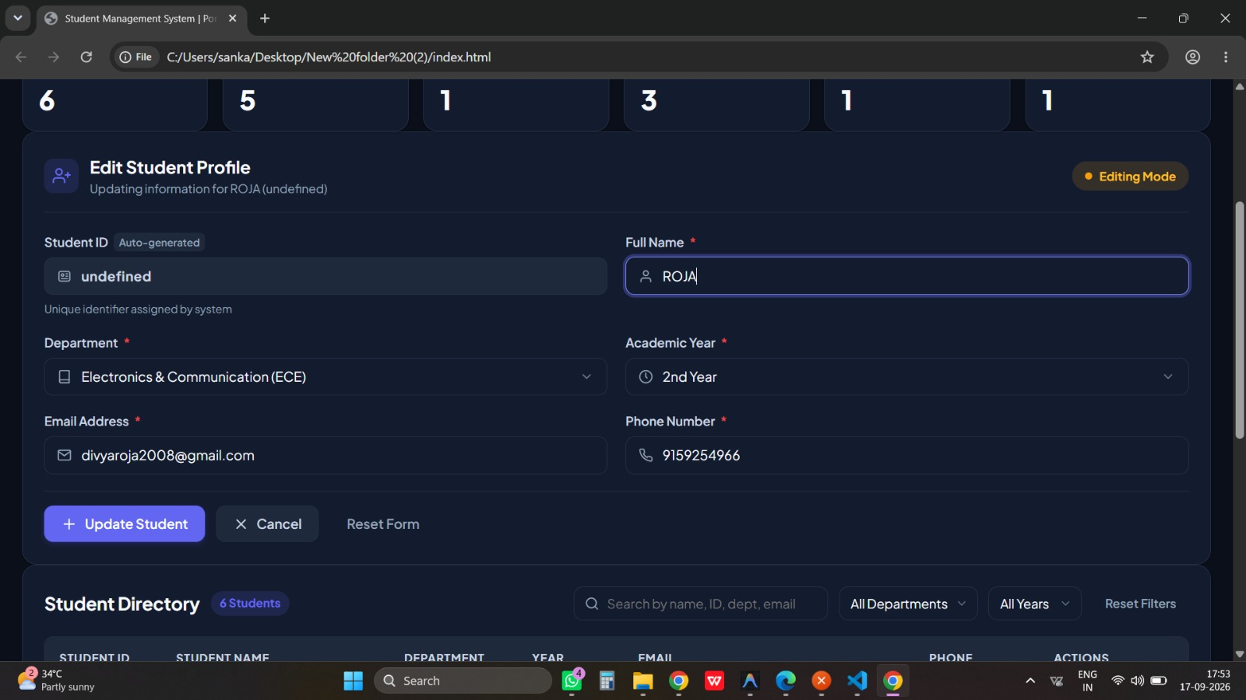
Figure 4:Delete Student Form
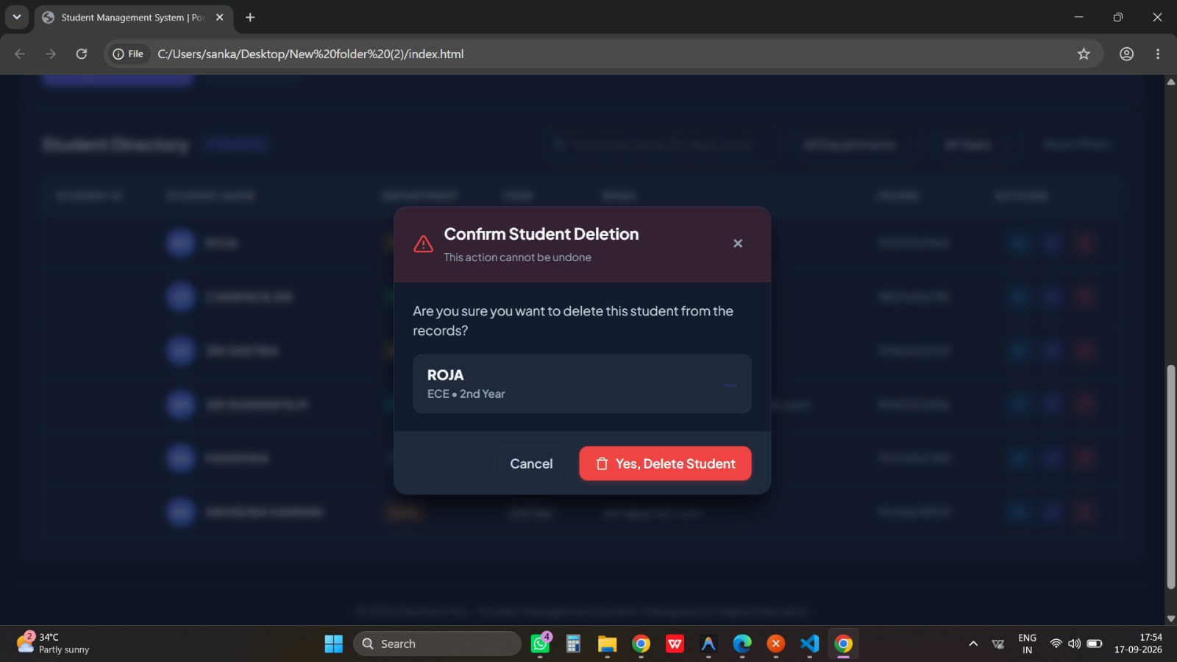

Figure 5: Backend API Online Status

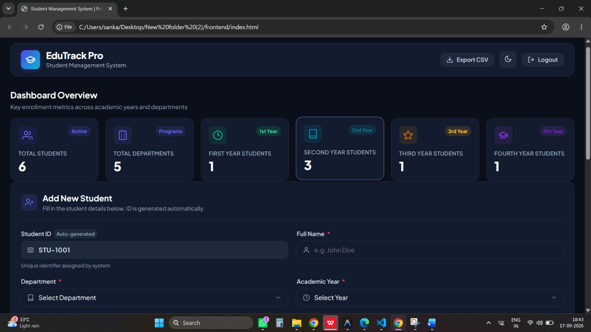

8. API Endpoint Documentation
The application uses REST API endpoints to provide communication between the frontend and Django backend.
Base URL: http://127.0.0.1:8000
Method | Endpoint | Description
GET | /api/students/ | Retrieve all students
POST | /api/students/ | Create a new student
GET | /api/students/&lt;id&gt;/ | Retrieve a specific student
PUT | /api/students/&lt;id&gt;/ | Update a complete student record
PATCH | /api/students/&lt;id&gt;/ | Partially update a student
DELETE | /api/students/&lt;id&gt;/ | Delete a student
GET | /api/students/stats/ | Retrieve dashboard statistics

Example POST Request
POST /api/students/
{
"student_id": "STU001",
"name": "Example Student",
"department": "ECE",
"year": "1st Year",
"email": "student@example.com",
"phone": "9876543210"
}

9. CRUD Implementation Details

9.1 Create
The Create operation allows a user to add a new student. The user fills in the Add Student form. JavaScript sends a POST request to the Django REST API. The backend validates the information and stores the new record in SQLite.

9.2 Read
The Read operation retrieves student information from SQLite through the Django REST API. JavaScript sends a GET request and displays the returned records in the student table and dashboard.

9.3 Update
The Update operation allows an existing student record to be modified. The user selects Edit, changes the required information, and saves the record. The frontend sends a PUT or PATCH request to the backend.

9.4 Delete
The Delete operation removes a selected student record. After confirmation, the frontend sends a DELETE request to the Django REST API and the selected record is removed from SQLite.
CRUD FLOW
CREATE -> Add Form -> POST -> Django -> SQLite
READ -> GET -> Django -> SQLite -> Display
UPDATE -> Edit -> PUT/PATCH -> Django -> SQLite
DELETE -> Delete -> DELETE -> Django -> SQLite

10. Testing Results
The application was tested to verify CRUD operations, API behavior, validation, dashboard statistics, search/filter functionality, and the SQLite database connection.
Test Case | Expected Result | Status
Start Django server | Server starts successfully | PASS
SQLite connection | Database connects successfully | PASS
Add student | Student record created | PASS
View students | Student records displayed | PASS
View single student | Selected record displayed | PASS
Edit student | Student information updated | PASS
Partial update | Selected field updated | PASS
Delete student | Student record deleted | PASS
Dashboard statistics | Correct statistics displayed | PASS
Search | Matching students displayed | PASS
Department filter | Selected department displayed | PASS
Year filter | Selected year displayed | PASS
Form validation | Invalid data rejected | PASS
The backend automated test suite reported 9/9 tests passed. The REST API verification also covered health, statistics, list, POST, GET-single, PUT, PATCH, and DELETE operations.

11. Installation and Execution Steps
Step 1: Open the Project
Open the Student-Management-System folder in VS Code or Antigravity.
Step 2: Install Dependencies
pip install -r ..\requirements.txt
Step 3: Create Migrations
python manage.py makemigrations
Step 4: Apply Migrations
python manage.py migrate

Step 5: Start Backend
python manage.py runserver 127.0.0.1:8000
Backend URL: http://127.0.0.1:8000/

Step 6: Start Frontend
cd frontend
python -m http.server 5500
Step 7: Open Application
Open Chrome and navigate to http://127.0.0.1:5500/

12. Challenges and Solutions

Managing Student Records
Challenge: Manual record maintenance can be time-consuming and difficult to organize.
Solution: A centralized web application was developed to manage records in one place.

Frontend-Backend Communication
Challenge: The frontend needs a reliable way to communicate with backend operations.
Solution: REST API endpoints were implemented using Django REST Framework.

Data Validation
Challenge: Invalid or incomplete information can reduce data quality.
Solution: Validation was implemented for required fields, email, Student ID, academic year, and phone number.

Database Configuration
Challenge: Different database servers can require additional setup.
Solution: SQLite was selected because it is lightweight and does not require a separate database server.

Searching and Filtering
Challenge: Finding a particular record can become difficult with many students.
Solution: Search, department filtering, and academic-year filtering were included.

13. Future Enhancements
- User authentication and role-based access for administrators and staff.
- Detailed student profiles with additional academic information.
- Attendance management.
- Marks and academic-performance management.
- PDF or Excel report generation.
- Email notifications for students and administrators.
- Additional charts and analytics on the dashboard.
- Cloud deployment for access from different locations.
- A mobile application using the existing REST API.
- Automated backup and recovery functionality.

14. Git Repository / Reference Details
Git can be used to maintain project history and GitHub can be used to store and share the source code. The repository should contain the frontend, backend, requirements file, README, and other project documentation.
Item | Details
Repository Name | Student-Management-System
GitHub Profile | https://github.com/SriSharanya981
Frontend | frontend/index.html, style.css, script.js
Backend | backend/manage.py, studentapi, students
Database | SQLite – db.sqlite3
Documentation | README.md

15. Conclusion

The Student Management System provides a simple and organized solution for managing student information. It implements the complete CRUD cycle, allowing users to create, read, update, and delete student records through an interactive web interface.
The system uses HTML, CSS, and JavaScript for the frontend, Django and Django REST Framework for the backend, and SQLite for persistent data storage. REST APIs provide communication between the frontend and backend, while validation helps maintain the correctness of student information.
The dashboard, search functionality, department and year filters, CRUD operations, and database integration make the system suitable for basic student record management. The project also provides a foundation for future enhancements such as authentication, attendance, marks management, report generation, and cloud deployment.
Overall, the project demonstrates the development of a complete CRUD-based full-stack web application and addresses the major documentation and development requirements of the provided project guidelines.

